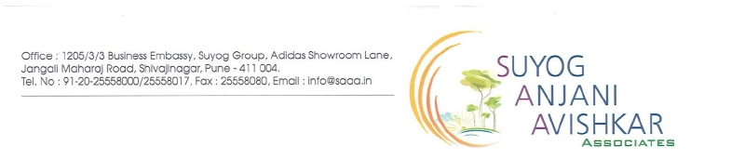

**NOTICE**

**Date: 26/05/2017**

To,

**Sai Avishkar Society Members, Dhayari, Pune.**

**Sub: Cleaning of Over Head Water Tanks (OHWT) & Underground Water Tanks (UGWT)**

Dear All Members,

This is to inform you that we have planned to clean all water tanks of **A, B, C, F and G Building** on **Dated. 30th May 17 and 31st May 17.**

So that drinking water supply will remain closed on **Tuesday (30th May 17)** from **11 AM to 9 PM.** And also utility & flush water supply will remain closed on **Wednesday (31st May 17)** from **11 AM to 6 PM.**

So kindly co-operate and keep sufficient water storage on these days.

Yours faithfully.

**Suyog Anjani Avishkar Associates.**